1. What is the difference between framework, library and module?
Module can be referred as a file containing a set of functions which are used in the program. Library can be defined as the set of modules and packages. Frameworks provides functionalities which can be selectively overridden. We cannot modify the code in a framework.
2. Explain IoC with an example.
Normally, when a user writes a program, the flow of control is dependent on the programmer. But while using the frameworks that doesn’t happen because the control of flow is in the hands of framework instead of the programmer. This is defined as Inversion of Control.
3. What is MVT Architecture? How is it different from MVC?
The term MVC stands for Model View Controller architecture.Model acts as the database for providing the required information. Here, the control is under the controller. It is the place where logics for the code are written. View acts as the frontend where the user requests something.
The term MVT stands for Model View Template. This architecture is used in Django Framework. It is an updated version of MVC where View plays part of the Controller and the Template plays part of the Views. The code logics can be implemented in View part and the Template part is used to display the response.
4. What is virtual environment? Why is it needed?
We need some dependencies on our system for our application to run on our computer. These dependencies may vary application to application. So, to manage multiple projects dependencies we create virtual environment where we can install them accordingly and those dependencies are bound to that environment only. It is needed so that we use only the required dependencies and other ones are not installed.
5. Create a virtual environment for your first Django application.
- sudo apt-get install python-virtualenv
- mkdir myProject
- cd myProject
- virtualenv django -p python3.6
- source bin/activate

6. Install Django through package manager.

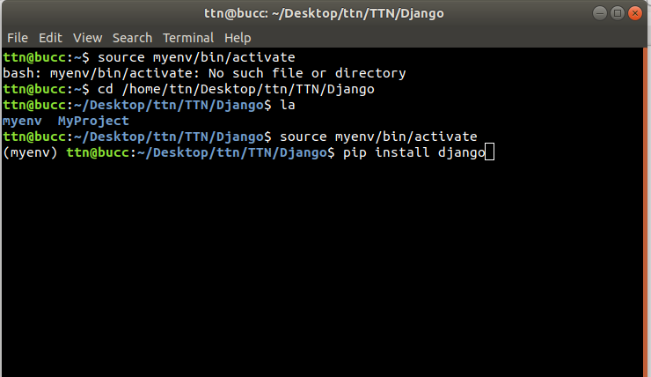

7. Create a project 'greetings' through django admin and run it.

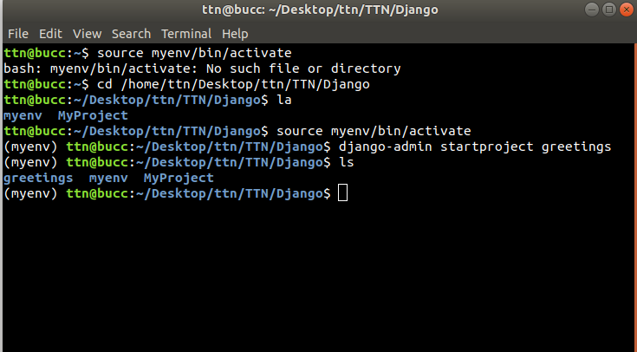

8. What is the difference between an app and a project? Create an app named greet and add it into your project greetings.
App consists of set of models, views, templates, tests whereas project is a collection of configurations and apps.

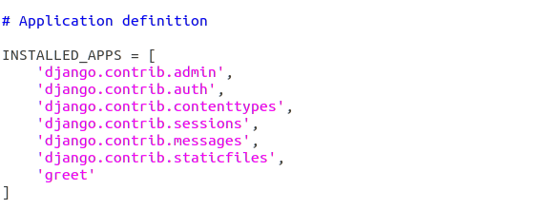

9. Define a view which will render Good Morning!! or Good Evening!! as per current system time.

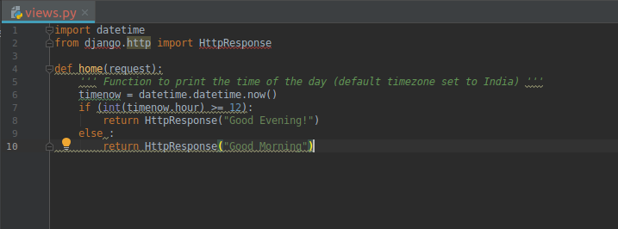

10. Register urls of admin portal at url mycustomadmin/, create super user and run it.

